Promotion Forecast Power App

Introduction – Why is this needed?
The Promotion Forecast Power App replaces a manually maintained Excel spreadsheet previously used by IT Service Desk leadership to track employee promotion eligibility, manager approvals, and override decisions. As an operationally owned application, it requires clear and standardized documentation to ensure continuity of support, reduce troubleshooting time, and allow seamless handoff between Service Desk engineers.
1. Application Overview Documentation – “The Basics”
Application Description
The Promotion Forecast Power App is a Power Apps Canvas application backed by a SharePoint list. It enables managers and IT Service Desk leadership to:
- View promotion eligibility data for Service Desk employees
- Validate calculated eligibility dates
- Apply manager-approved override dates when required
- Capture justification comments for audit and review
The app improves data accuracy, access control, and process transparency compared to the prior Excel-based workflow.
Ownership Details
- Application Owner: IT Service Desk Operations
- Primary Technical Owner: Elliott Keskemety, IT Systems Engineer
- Primary QA Tester: Crystal Croasmun, IT Qlty Assur Anly
- Business Stakeholders: IT Service Desk Management
  - Original Requestor: Zakiya Middleton, IT Service Desk Manager
- Support Group: IT Service Desk (Operations)
  - Version Information
- Application Type: Power Apps Canvas App
- Current State: MVP Complete
  - Go live: 6/26/26
  - Sunset date: 7/27/26
- Versioning format – Automated by Power Apps
- Release Model: Incremental updates as process requirements evolve
- Release Notes: Maintained in ITSD documentation repository per version - Release Notes - ITSD Power Apps.xlsx
Dependencies
- SharePoint Online (primary data store)
- Microsoft Power Apps
- Power Automate (supporting automation/validation)
- MS Entra ID (authentication)
- Updates to job minimums via HR express

2. Technical Architecture and Configuration
System Architecture
Frontend: Power App: ITSD Promotion Forecast Tracker
Backend: SharePoint List – Forecast Spreadsheet [https://progressiveinsurance.sharepoint.com/sites/ITSDFrontline/Lists/2026%20Forecast%20Spreadsheet/AllItems.aspx}
Replacing 2026 Forecast Spreadsheet
Automation: Power Automate flows for validation and downstream processing – Promotion Forecast Automation
Architecture diagrams should be maintained in Draw.IO format and stored alongside this document.

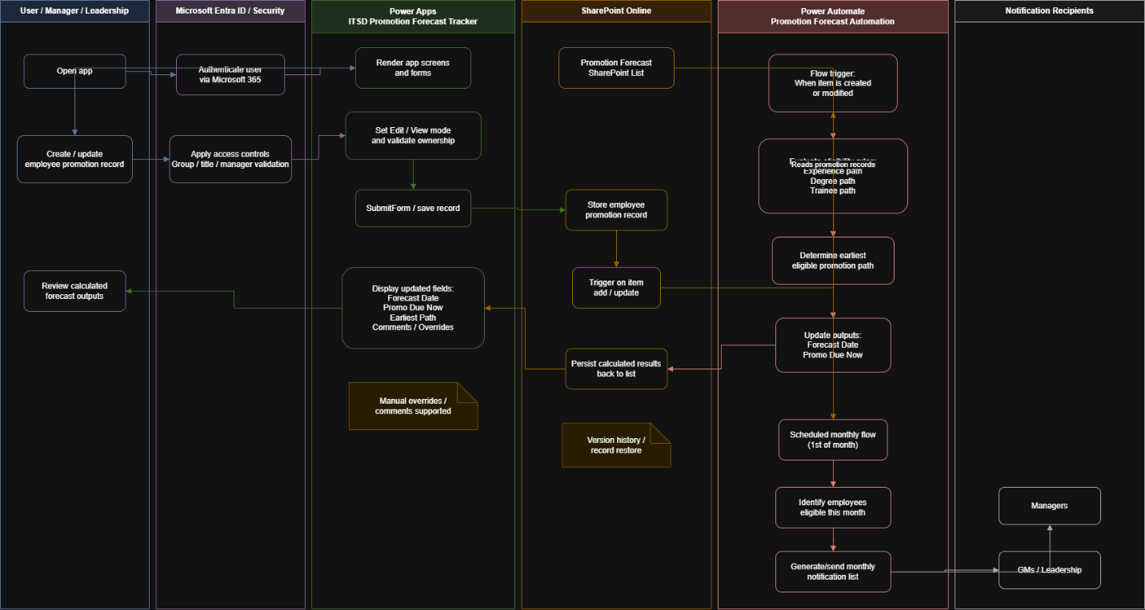
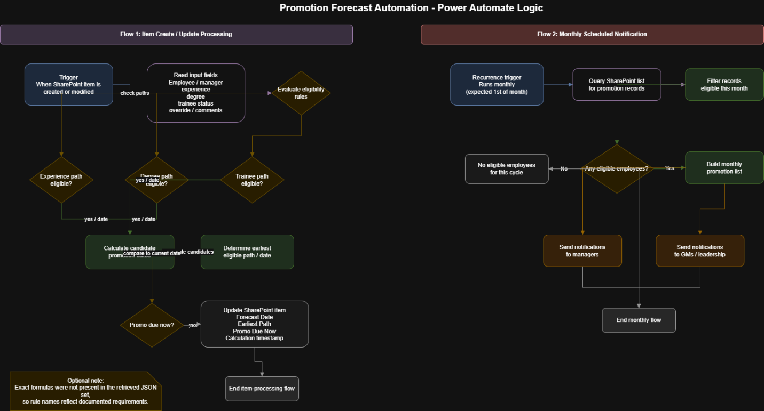
Infrastructure Details
- Fully cloud-hosted (Microsoft 365)
  - No on-premise infrastructure dependencies
- SharePoint Online provides data availability and resiliency
- Data flow: Create/update record → SharePoint → Flow triggered → eligibility calculated → results written back → monthly notification process.
Resiliency Details
- If SharePoint Online is unavailable, the application is read/write unavailable
- Recovery supported via SharePoint and Power Apps version history for rollback.
- No manual fallback process within the app (Excel maintained externally as contingency if needed)
Configuration Settings
- Application variables control Edit/View modes and ownership validation
- Save lifecycle explicitly controlled via Submit Form orchestration
- Calculations for dates based on the min requirements for promotion as found in job description based approved by HR
- Managers can override calculations at their discretion
Integration Points
- Power Automate flow(s) triggered from Power Apps
- No external APIs beyond Microsoft 365 services

3. Access and Security Information
User Roles and Permissions
Multi-layered authorization including group membership, title validation, and app-level manager validation.
- Read Access: All authorized IT Service Desk and IT Service Desk Operations managers
For access user must be member of security group P-U-ITSDCA-P and have one of the following titles:
  - “it service desk manager",
  - "it group manager",
  - "it manager",
  - "it mgmt edge participant"
- Edit Access: Restricted to the employee’s assigned manager
Manager validation is enforced within the app logic written in screens and onstart code, not solely via P-U-ITSDCA-P Permissions.
Authentication Methods
- Authentication via MS Entra ID (Microsoft 365 sign-in)
- No local credentials or alternate authentication methods
Security and Access Procedures
- Access to app governed by M365 Security group membership and title
- Access to SharePoint List governed by MS Group – ITSD Managers
- PIMS / P-U-ITSDCA-P entitlement requirement.
Audit Logs
- SharePoint version history tracks record changes
- Power Automate run history available for troubleshooting

4. Support and Maintenance Procedures

Incident Management
- Incidents tracked through standard ITSD processes [pending]
- Escalate to IT Systems Engineering for application defects [pending]
Maintenance Schedules
- No fixed maintenance window
- Dependent on M365 platform availability
Backup and Recovery
- SharePoint Online version history acts as primary recovery mechanism
- Record-level restore available via SharePoint
- Automated email from Power Automate if flow fails to owners of the app

5. Troubleshooting and Knowledge Base
Known Issues
- The app uses multiple forms that must be submitted in the correct order, or data may not save properly
- The comments field must be set up to allow multiple lines of text, or user input may not be saved or displayed correctly
- Edit access failures: validate manager mapping
- Save failures: confirm SharePoint list availability and flow health
- UI issues: verify Power Apps published version
Important Log Locations
- Power Automate flow run history
- SharePoint list version history
Diagnostic Tools
- Power Apps Monitor
- Power Automate run diagnostics

6. Change and Release Management
Change Requests
- Changes proposed
  - Through IT Service Desk Operations leadership
  - Fixes for issues or defects identified via testing or incident processes.
- Reviewed prior to production deployment and tested before production release
Release Notes
- Logged per update in ITSD documentation repository
Testing Strategy / Workbook
- QA Tester: Crystal Croasmun
- Smoke testing for:
  - Edit permissions
  - Save flow (main form + comments)
  - Override validation logic
Rollback Procedures
- Revert to previous app version in Power Apps
- Restore SharePoint data via version history if required

7. Training and User Documentation
User Guides
No user guide requested from customer as self-explanatory with limited user group.

8. Compliance and Licensing
Compliance and Data Retention
- Contains internal employee eligibility data
- Retention governed by HR minimum requirements policies
Licensing Information
- Power Apps usage covered by Microsoft 365 premium licensing thorugh the P-U-ITSDCA-P membership.
Data Protection
- Data protected under Microsoft 365 security controls
- No external data storage i

Global Document Storage and Update Expectations
Storage Location
- ITSD Ops SharePoint (preferred)

